EX NO: 4 DASHBOARDS IN ZOHO CREATOR

AIM
To create an interactive Vehicle Service & Repair Request Management dashboard using Zoho Creator to monitor service requests, repair status, priority levels, and other important service information through reports, charts, and summary panels.

PROCEDURE
- Open the Vehicle Service application in Zoho Creator.
- Create a new Dashboard/Page named Vehicle Service & Repair Request Management.
- Add the required reports, such as All Service Requests and Repair Status, to the dashboard.
- Create summary panels to display important information:
  - Total Service Requests o Completed Repairs o Cancelled Requests o Pending Requests
- Add charts to visualize the service request data:
  - Request Status using a Pie Chart o Priority Level using a Bar Chart o Repair Status using a Donut or Radar Chart
- Arrange the reports, charts, and summary panels properly on the dashboard.
- Add a search option to easily find a service request by vehicle number, customer name, or request ID.
- Preview the dashboard and verify that the reports and charts display the correct service request data.

OUTPUT
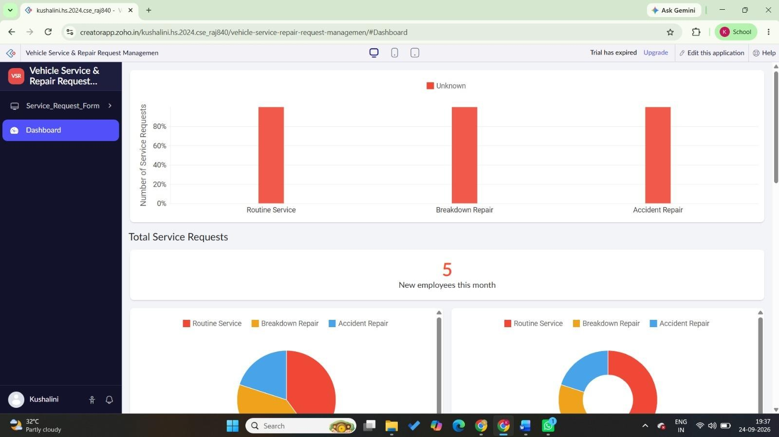

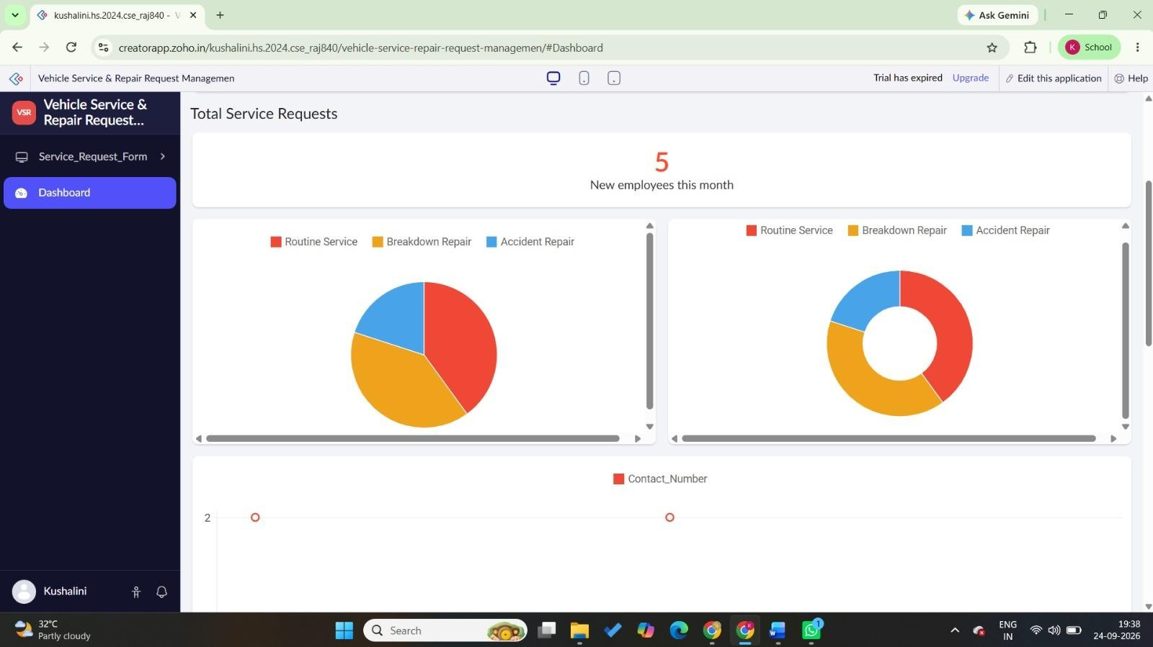

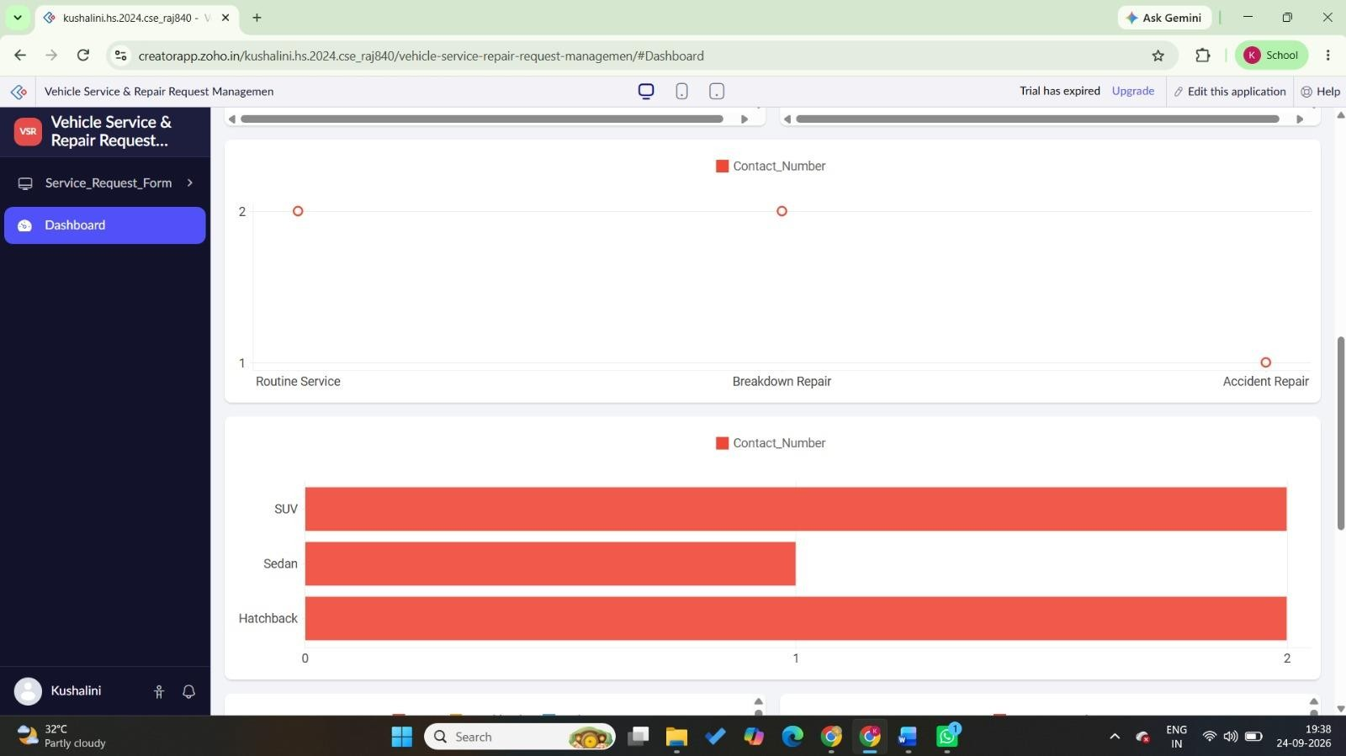

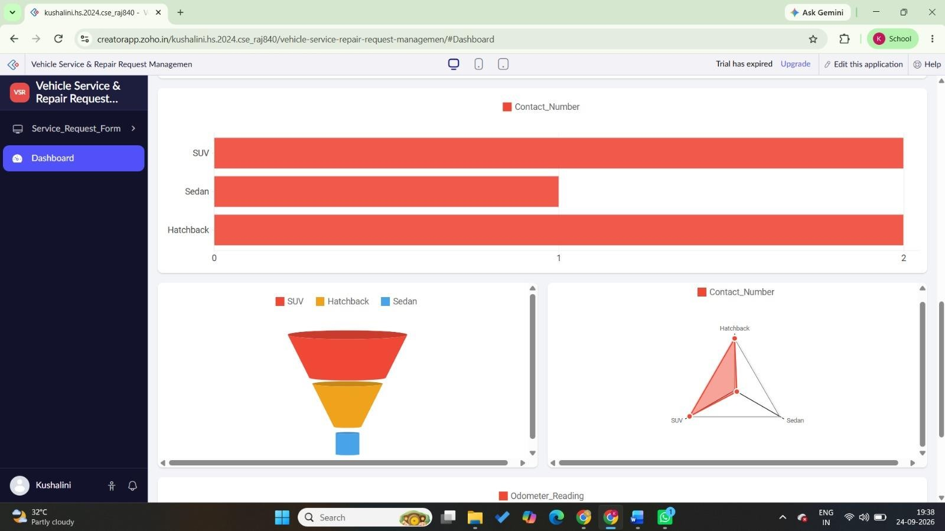
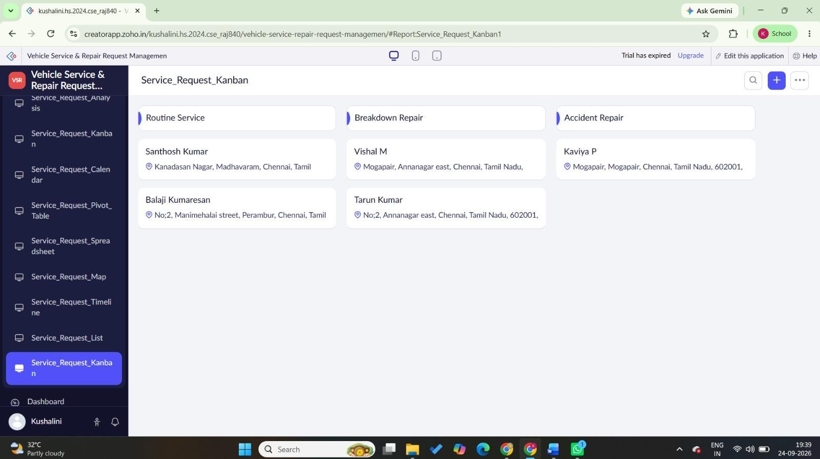

RESULT
Thus, an interactive Vehicle Service & Repair Request Management dashboard was successfully created in Zoho Creator to monitor service requests, repair status, priority levels, and other service-related information using reports, charts, and summary panels.

